**::C++ 25 Fall 2016:: Assignment 1 Computer Concepts**

**Name:**

**Student ID:**

Why are we starting with Intro to Computer Concepts the first 2 assignments, instead of jumping straight into coding? (Please write short answer below.)

Proficient coding requires an understanding of computers and how they work. If we are to be successful in writing efficient code, we need to have a working knowledge of a computer, its hardware, and its operations.

**Computer Literacy: Work Smarter and Harder**

* You must become proficient in navigating the computer efficiently.
* You must become proficient in organizing and accessing e-mail efficiently.
* Copy / Paste
* Utilize keyboard Shortcuts: command + C (Mac) / CTRL + C (Windows), etc.

List a few keyboard shortcuts below.

1. CTRL + N - New window or document
2. ALT + F4 - Close window or application
3. CTRL + W - Close tab

List a few ways a computer makes doing school work easier.

1. Computers give access to websites which aids in research
2. Computers allow fast transferral of files
3. Computers facilitate quick communication over long distances

How do you think the concepts above relate to computer programming?

Computers are used for many different purposes and in different ways. Computer programs should do the same.

(Please define in your own words all concepts with underline and bold font)

**What is a computer?**

A collection of switches that performs calculations

List a few examples of different types computers.

1. Desktop
2. Laptop
3. Tablet

**Computer Hardware:** Physical Components

**Visualize:** Please go locate the physical components inside the computers in the room or attach a photo from the internet. Feel free to discuss with other students. (~25 minutes then discussion)

**Central Processing Unit (CPU)-** 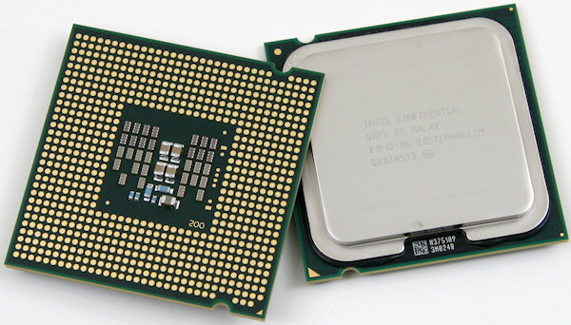

**Describe a human body part the CPU is similar to.**

brain

**Motherboard -**

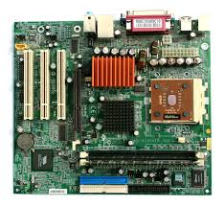

**Describe a human body part the Motherboard is similar to.**

Spine

**Locate the Hard drive -**

Long-term memory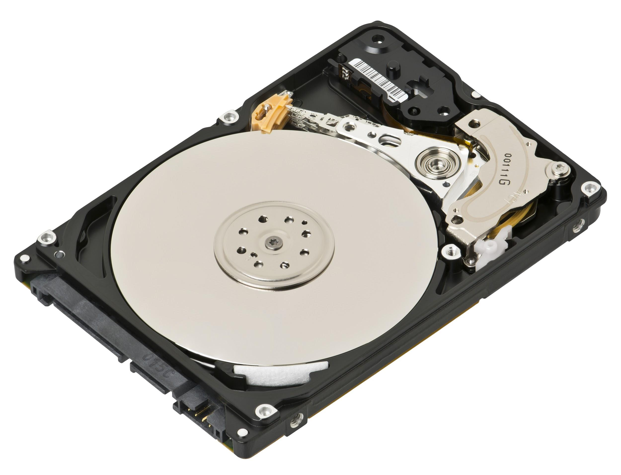

List a few examples of storage devices that are somewhat similar to a hard drive.

1. Flash Drive
2. Memory Card
3. Compact Disk

**Locate the power supply-**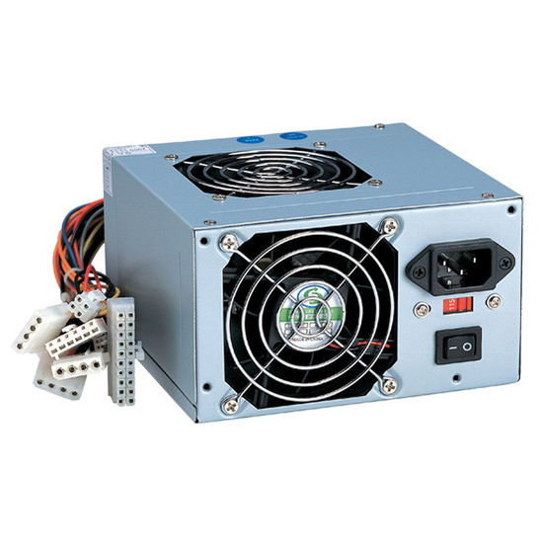

**Describe a human body part the Power Supply is similar to.**

Heart

**RAM-**

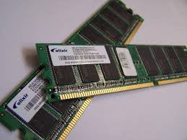

Random Access Memory - Short Term Memory

**How does RAM storage differ from the Hard Drive?**

Ram is volatile. When current stops running through the electronics, it forgets what was stored there.

List a couple of examples of hardware input devices

1. Keyboard
2. Mouse

List a couple of examples of hardware output devices

1. Speakers
2. Monitor

List a couple of examples of devices that provide for both input and output devices

1. Touchscreen
2. Gaming headset

**Computer Software-**

A set of instructions to control a computer’s hardware. It can also interact with other software.

What are some types of software?

1. System Software - controls the functions of the overall computer system
2. Application/Program Software

|  |  |  |
| --- | --- | --- |
| **Operating System-** The interface that bridges the gap between hardware and software | | |
| **List 3 types of Operating system for your Desktop Computer** | | |
| **Linux Ubuntu** | **Macintosh OS X** | **Windows XP** |
| **What programming language or languages are most Desktop operating systems composed of? C** | | |
| **List 3 types of Operating System for your Cell Phone** | | |
| **Android L** | **iOS 7** | **Linux Ubuntu** |
| **What programming language or languages are most Mobile operating systems composed of?** C/C++ | | |

|  |  |  |
| --- | --- | --- |
| **Web Browser -** The software used to connect to the World Wide Web | | |
| **List 3 types of Web Browsers for your Desktop Computer** | | |
| Chrome | Firefox | Opera |
| **What programming language or languages are most web browsers for your Desktop composed of?** C++ | | |
| **List 3 types of Web Browsers for your Cell Phone** | | |
| Chrome | Safari | Internet Explorer |
| **What programming language or languages are most web browsers for your mobile device composed of?** C++ | | |
| **What programming language or languages does your web browser interpret?** HTML, CSS, JavaScript | | |

|  |  |  |
| --- | --- | --- |
| **What programming languages are crucial for building websites?** HTML | | |

|  |  |  |
| --- | --- | --- |
| **Why Learn C++? What can you build with C++?** You can build anything with C++. Many languages also reference C++ so once it is learned well, any other language is mostly syntax. | | |

**How are software and hardware connected?** Usually software controls hardware

**Is the software available for your desktop the same as the software you use for your mobile device (Shared software like Firefox or Google Chrome)?**

**Please explain your answer.**

It is in a different version. Because mobile devices and desktop/laptop computers have different hardware and operating systems, the software that addresses them is usually custom for that use case. Mobile devices must be small to be mobile. Many times, the hardware included is not as powerful as what might be included in something that does not have the same size limitation.

**LAB ASSIGNMENT 1**

**Define: Phone or Computer Specifications-**

The list of capabilities of hardware

|  |  |
| --- | --- |
| **COMPARE THE 2 Personal Computers you have with you now.** | |
| **Your Cell Phone** | **The laptop you plan to use for class or lab computer** |
| MANUFACTURER | |
| Motorola | Lenovo |
| PROCESSOR TYPE | |
| Quad-core 2.5 GHz Krait 400 | Intel Core i7-3770 CPU @ 3.40 GHZ (x8) |
| (C) DRIVE MEMORY CAPACITY | |
| 32 GB | 931 GB |
| RAM CAPACITY | |
| 2 GB RAM | 8 GB |
| SCREEN SIZE | |
| 5.2 inches | 24 Inches |
| NUMBER AND TYPE OF EXPANSION PORTS | |
| None | Two 5.25 inch external bay (Optical Disk Drives)  Two 3.5 inch internal bay (HDD)  One 3.5 inch external bay (Memory card reader)  2 ODD support  2 HDD support  Two High speed USB 2.0 (Front)  Two high speed USB 2.0 (back)  Four high speed USB 3.0 (back)  Two audio connectors (microphone and headphone) on front panel  One integrated VGA port  Two audio connectors (audio line in and audio line out) on rear panel  One RJ45 connector  Two PCI full height  One PCI Express x1  One PCI Express x16 |
| PRICE | |
| $100 | **$1,375.85** |
| Any Additional Characteristics that differ between your cell phone and your laptop. | |
| Operating System | |